# CS 499 Module One Assignment Template

Complete this template by replacing the bracketed text with the relevant information.

1. **Self-Introduction:** Address all the following questions to introduce yourself.
   1. How long have you been in the Computer Science program?

**I have been in the Computer Science program for four years.**

* 1. What have you learned while in the program? List three of the most important concepts or skills you have learned.
  2. **I have learned the best practices of coding.**
  3. **I have learned how to integrate applications with a database.**
  4. **I have learnt basic approaches to creating software like coding and writing a pseudocode that acts as the guide to software development.**
  5. Discuss the specific skills you aim to demonstrate through your enhancements to reach each of the course outcomes.

**I intend to use most of the skills I have learnt in this class, for example coding which involves writing instructions in a programming language to create software applications, websites, or computer programs. I intend to use best practices in coding to promote maintainability, readability, efficiency, and error-free programming by following standards, using meaningful names, documenting code, and utilizing modular and reusable principles. Lastly, I intend to use database skills to connect software applications to databases, allowing data storage, retrieval, and manipulation.**

* 1. How do the specific skills you will demonstrate align with your career plans related to your degree?

**By acquiring new skills, I will boost my capacity to develop problem-solving tools, leading to improved performance in both my professional and personal endeavors. I plan to utilize elements such as databases, algorithms, data structures, and software design engineering to achieve these goals.**

* 1. How does this contribute to the specialization you are targeting for your career?

**With the technical skills I have acquired at work and the education from this course, I aim to advance my career and aspire to secure a promotion in the research and development field.**

1. **ePortfolio Set Up:**
   1. Submit a **screen capture** of your ePortfolio home page that clearly shows your URL.
      1. You already have a repository in GitHub where you uploaded projects in previous courses. Your ePortfolio will reside in GitHub but can link to work at other sites, such as Bitbucket.

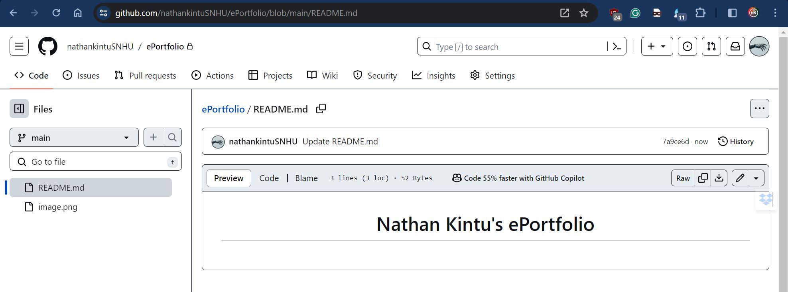

<https://nathankintusnhu.github.io/ePortfolio/>

* 1. Use the GitHub Pages link in the Resource section for directions on:
     1. How to create your GitHub website and publish code to GitHub Pages
     2. Issues, such as adding links to other sites
  2. Paste a screenshot of your GitHub Homepage with your URL clearly showing in the space below.

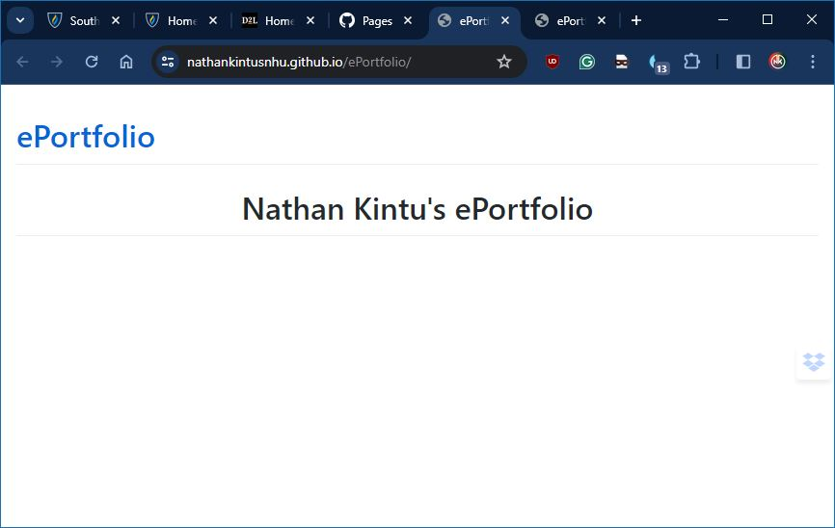

1. **Enhancement Plan:** 
   1. **Category One:** Software Engineering and Design
      1. **Select an** **artifact** that is **aligned with** **the** software engineering and design **category** and explain its origin. Submit a file containing the code for the artifact you choose with your enhancement plan.

I have been approached by a local concrete block manufacturing company to develop a system that calculates the number of blocks needed to cover a specific area based on customer requirements. The company produces two variants of blocks: standard blocks and colored blocks that can be customized according to the user's preference.

**Requirements of the system.**

The system should display all the ingredients and instructions.

1. Cement

2. Aggregates (sand, gravel, crushed stone)

3. Water

4. Color pigments (optional)

5. Mold

Note: The proportions of the ingredients may vary depending on the desired strength, density, and other properties of the concrete blocks.

**Instructions:**

1 bag of cement

5 bags of aggregates

20 liters of water

20 cups of Color pigment

1 Mold (457.2cm3)

1. Measure out the required amount of cement,

2. Mix the cement and aggregates together in a concrete mixer until they are evenly distributed.

3. Slowly add water to the mix, while continuing to mix, until the desired consistency is reached. The mix should be workable but not too wet.

4. If using color pigments, add to the mix and continue mixing until they are evenly distributed.

5. Prepare the mold for the concrete blocks. Make sure it is clean and lubricated to prevent sticking.

6. Fill the mold with the concrete mix, making sure to compact it well to remove any air pockets.

7. Level off the top of the mold with a trowel or screed to create a smooth surface.

8. Allow the concrete blocks to cure and set for a specific period, typically 24-48 hours, before demolding.

9. Carefully remove the concrete blocks from the mold and place them on a flat surface to continue curing for a few more days.

10. Once fully cured, the concrete blocks are ready to be used for construction.

* + 1. **Describe** a practical, well-illustrated **plan** for enhancement in alignment with the category, including a pseudocode or flowchart that illustrates the planned enhancement.

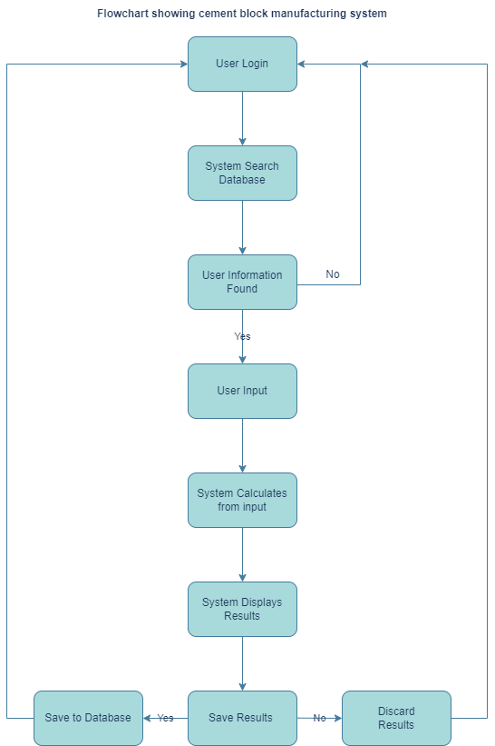

For this category of enhancement, consider improving a piece of software, transferring a project into a different language, reverse engineering a piece of software for a different operating system, or expanding a project’s complexity. These are just recommendations. Consider being creative and proposing an alternative enhancement to your instructor.

Think about what additions to include to complete the enhancement criteria in this category. Since one example option is to port to a new language, that is the kind of scale that is expected. This does not mean you need to port to a new language but instead have an equivalent scale of enhancement. Underlying expectations of any enhancement include fixing errors, debugging, and cleaning up comments, but these are not enhancements themselves.

* + 1. Explain how the planned enhancement will **demonstrate** specific **skills** and align with course outcomes.
       1. Identify and describe the specific skills you will demonstrate that align with the course outcome.

**I will showcase my proficiency in implementing Create, Read, Update, and Delete (CRUD) operations in a database, along with utilizing an algorithm to calculate the required number of blocks for a given area to be covered.**

* + - 1. Select one or more of the course outcomes below that your enhancement will align with.
* Design and evaluate computing solutions that solve a given problem using algorithmic principles and computer science practices and standards appropriate to its solution while managing the trade-offs involved in design choices.

Course Outcomes:

* Employ strategies for building collaborative environments that enable diverse audiences to support organizational decision-making in the field of computer science.
* Design, develop, and deliver professional-quality oral, written, and visual communications that are coherent, technically sound, and appropriately adapted to specific audiences and contexts.
* Design and evaluate computing solutions that solve a given problem using algorithmic principles and computer science practices and standards appropriate to its solution while managing the trade-offs involved in design choices.
* Demonstrate an ability to use well-founded and innovative techniques, skills, and tools in computing practices for the purpose of implementing computer solutions that deliver value and accomplish industry-specific goals.
* Develop a security mindset that anticipates adversarial exploits in software architecture and designs to expose potential vulnerabilities, mitigate design flaws, and ensure privacy and enhanced security of data and resources.
  1. **Category Two:** Algorithms and Data Structures

1. **Select an artifact** that is **aligned with the** algorithms and data structures **category** and explain its origin. Submit a file containing the code for the artifact you choose with your enhancement plan. You may choose work from the courses listed under Category One.

**The section in my system that corresponds to Algorithms and Data Structures will be responsible for performing calculations to determine the number of blocks required for a particular area to be covered.**

* 1. **Category Three: Databases**

For this category of enhancement, consider adding more advanced concepts of MySQL, incorporating data mining, creating a MongoDB interface with HTML/JavaScript, or building a full stack with a different programming language for your artifact. These are just recommendations; consider being creative and proposing an alternative enhancement to your instructor. Note: You only need to choose one type of enhancement per category.

Think about what additions to include to complete the enhancement criteria in this category. Since one example option is to port to a new language, that is the kind of scale that is expected. Perhaps you might increase the efficiency and time complexity of an algorithm in an application and detail the logic of the increased time complexity. Remember, you do not need to port to a new language but instead have an equivalent scale of enhancement. Underlying expectations of any enhancement include fixing errors, debugging, and cleaning up comments, but these are not enhancements themselves.

* + 1. Explain how the planned enhancement will **demonstrate** specific **skills** and align with course outcomes.

**This section of my project focuses on utilizing a database specifically for employee authentication and storing relevant user information. I have chosen to employ MySQL as the database management system for this section.**

1. **ePortfolio Overall Skill Set**
   1. Accurately describe the **skill set** to be illustrated by the **ePortfolio** **overall**.
      1. Skills and outcomes planned to be illustrated in the code review

**I will demonstrate the implementation of good coding practices, including the use of comments, thorough code documentation, meaningful naming conventions, modular design, proper error handling, consistent code formatting and indentation, application of the DRY principle, utilization of version control systems, and comprehensive testing. By adhering to these practices, we improve code readability, maintainability, collaboration, and overall code quality, enabling efficient development and enhancing the overall user experience.**

* + 1. Skills and outcomes planned to be illustrated in the narratives.

**I will showcase my skills in designing the user interface (UI) of the software, implementing algorithms for block calculations, and incorporating data management through database operations. This will include demonstrating the creation, updating, reading, and deletion of data from the database.**

* + 1. Skills and outcomes planned to be illustrated in the professional self-assessment

**I will evaluate my strengths and effectively demonstrate my skills in the areas where I have confidence and proficiency.**